**PowerBI Steps**

**Part 1 - Loading Data**

1. Open A new PowerBI file
2. Home
3. Get data
4. Text/CSV
5. Citi Bike Data V2.csv
6. Change ‘Data Type Detection’ from ‘Based on first 200 rows’ .to ‘Do not detect data types’ (So that we can go through the full experience, PowerBI will not always guess right)
7. Transform Data
8. A window called ‘Power Query’ will open

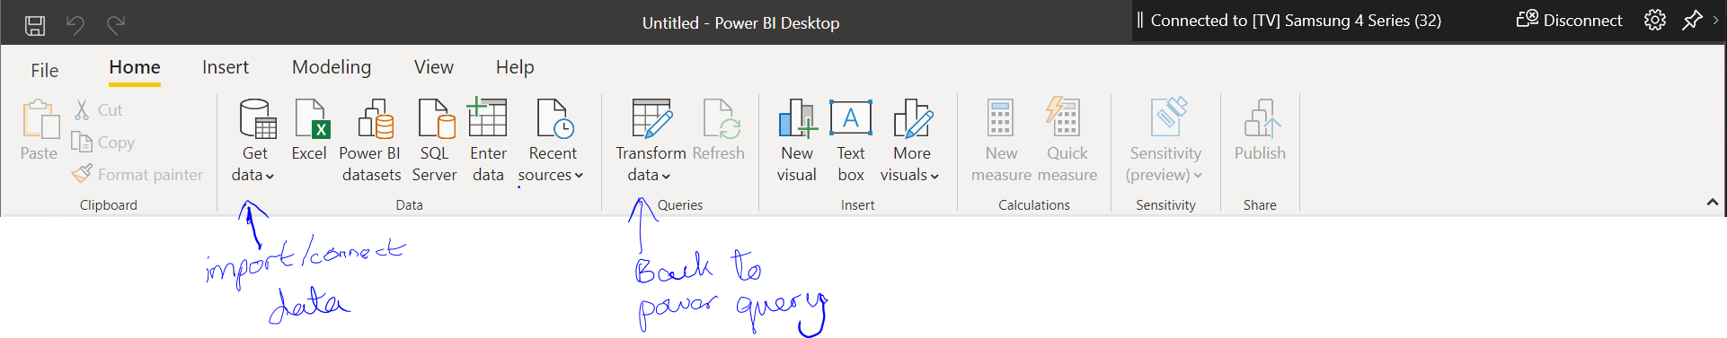

**Part 2 – Cleaning Data**

1. On the right side of the window you will see ‘Query Settings’ which lists the applied cleaning steps. At the moment it should show ‘Source, Promoted Headers, Changed Type’ . We are going to delete ‘Changed Type’ and ‘Promoted Headers’ so you know how to add these steps when they do not automatically apply.
2. Click the X next to ‘Changed Type’ and ‘Promoted Headers’ under ‘Applied steps’ in ‘Query Settings’
3. On the Home Tab navigate to the ‘Transform’ Section and pick ‘Use First Row As Headers’. This will change the first row to headers and automatically add ‘Changed Type’ as a step after ‘Promoted Headers’.
4. Delete ‘Changed Type’ Step

Note: There are a few ways to change data type

1. First column ‘tripduration’ click the ‘ABC’ next to the column title. (data type change way 1)
2. Pick Whole Number (There are no decimals)

Note: you can hold control to select specific columns or hold shift to select every column

between your first and second click.

1. Hold control or shift and select the columns ‘starttime’ and ‘stoptime’.
2. Click the ‘Transform’ tab
3. In the ‘Any Column’ section click the arrow next to ‘Data Type’.
4. Pick ‘Decimal Number’ then click again and pick ‘Date/time’. (PowerBI can be odd about changing text data to date format.
5. Make sure you pick ‘add new step’ on the pop up window. Both columns data type symbol should now be a calendar with a clock in the corner.
6. Find the “id:”, “station name”, ‘Birth Year’ and “gender” columns and make sure they are se as data type text “ABC” so that PowerBI won’t aggregate them.
7. Go to the last column and right click the column called ‘Junk’
8. Pick ‘Remove’
9. Navigate to <https://www.citibikenyc.com/system-data> to see their Gender key.
10. Right Click the ‘gender’ column and pick ‘duplicate column’, repeat for the “birth year” column.
11. Rename the new gender column ‘Gender Name’ by double clicking the column name or right clicking and scrolling, then rename the new birth year column “Birth Year Math”.
12. Right click ‘Gender Name’ and pick ‘Replace Values’. Value to find is ‘1’, Replace with is ‘Men’ (do not include the quote marks).

Note: if you mess up the ‘Replaced Value’ step click the ‘cog’ symbol next to ‘Replaced Value’ under ‘Applied Steps’ and change what is needed.

1. Repeat step 18 but replace ‘2’ with ‘Women’.
2. Now we are going to investigate the ‘NULL’ birth years. Click the down arrow next to the ‘birth year’ column. You should see a list of the distinct birth years in the column as well as ‘blank’ and ‘NULL’ at the bottom. You can click ‘Load More’ if the value you want is not there.
3. Untick ‘(Select All) and tick ‘NULL’ (Null is at the bottom, but you can search for it).
4. On ‘usertype’ pick ‘customer’ and deselect subscriber.
5. All of the showing data should be for ‘Day pass users’
6. Replace the ‘NULL’ values in the ‘birth year’ column with ‘Day Pass’, Do the same for the ‘0’ values in ‘Gender Name’, then replace the “NULL” values in “Birth Year Math” with nothing.
7. Change the data type of “Birth Year Math” to “Whole Number”
8. Remove the ‘filtered rows’ step/steps from ‘applied steps’ (if you don’t then only the showing data will be available for your visualisations later)
9. On ‘birth years’ click the down arrow and ‘sort by ascending’.
10. Note that there are blanks as well as people older than the oldest living New Yorker at the time. Untick and birth years that make someone older than 90 <https://en.wikipedia.org/wiki/List_of_American_supercentenarians>
11. Go to the ‘Home’ tab, in ‘Reduce Rows’ section ‘Remove Rows’
12. Click ‘Remove Blank Rows’.
13. Click ‘Close & Apply’ (if you just close it won’t apply your steps).
14. If you accidentally click just ‘Close’ It will ask you on the dashboard if you want to apply or discard your unapplied steps.

**Part 3 – Building**

1. At the bottom left you will see ‘Page 1’ click the plus next to it and add three new pages.
2. Double click ‘Page 1’ tab name to rename to ‘Citi Bike Dashboard’. Rename the rest of the pages ‘Graphs’, ‘Bubble Maps’ and ‘Formatting’ respectively.
3. Go to the ‘View’ Tab at the top pick the second theme
4. Click the down arrow next to the themes.
5. Pick ‘customise current theme’
6. ‘Text’ on the left under ‘General’ Font should be ‘Segoe UI’
7. ‘Title’ font should be changed to ‘Segoe Bold’
8. ‘Cards and KPIs’ Should be changed to ‘Segoe UI’ also.
9. Go down to ‘Page’ change ‘page background’, ‘colour’ to “#E6E6E6” and transparency to 0%.
10. Apply.

**Part 4 – Bar Graphs and Pie Charts**

1. Go to the ‘Graphs’ Tab.
2. On the right you will see two sections. ‘Fields’ and ‘Visualizations’.
3. Under visualisations click or drag ‘Clustered Column Chart’ (first row 4th from left).
4. With the new chart selected, in ‘Fields’ click ‘Gender Name’ or drag it to the space under ‘Axis’ in the ‘Visualisations’ section
5. Click or drag ‘Trip Duration’ and make sure it ends up in the ‘Values’ box.
6. Click the down arrow next to trip duration (under visualisations) and pick ‘Average’
7. With your graph selected click the paint roller brush in the Visualisations section.
8. Expand the ‘x axis’ section.
9. Change ‘text size’ to 10 for ‘women man, day pass’ to change.
10. Change ‘inner padding’ to ‘30%’ to increase space between columns
11. Change ‘Axis Title’ to ‘Gender’.
12. Change ‘Title Text Size’ to 12
13. Expand ‘y axis’
14. Change ‘Text size’ to 10
15. Change ‘Display Units’ to ‘Thousands’
16. Change ‘Axis Title’ to ‘Average Trip Duration’.
17. Expand ‘Data Colours’ toggle ‘Show All’ to ‘on’.
18. Pick colours for each bar. For ‘Day Pass’ I used #4D9532 by opening ‘more colours’ in the colour selector for ‘Day Pass’.
19. Open Title and change ‘Title Text ‘ to Average Trip Duration by Gender
20. Drag a ‘Q/A’ visualisation type onto the page (looks like a square speech bubble).
21. Type “total tripduration by gender name” in the search bar. It should form a horizontal cluster column chart.
22. “I don’t use this feature as it is difficult to format”. Most of the format features are missing (x axis, y axis, title etc…)
23. Recreate the visual that the Q/A made manually. Tip (click the horizontal clustered column chart with the Q/A chart selected).
24. The Axis and Values should be prefilled. Click the down arrow next to ‘tripduration’ and check that ‘Sum’ is picked.
25. Click the ‘Average Trip Duration by Gender’ Visual we just made.
26. Under ‘Home’ in the ‘Clipboard’ section click the ‘Format Painter’ (looks like a paintbrush).
27. Then click the ‘trip duration by gender name’ visualisation to copy the format of our first visual over.
28. We must manually change some things like Titles.
29. On the horizontal cluster column chart Double click ‘Gender Name’ in the ‘Axis’ box
30. Rename ‘Gender Name’ to ‘Gender (this will only change the title for this visualisation).
31. Do the same for ‘trip duration’ in ‘Values’ but change it to ‘Total Trip Duration”
32. Notice the Visualisation Title is now acceptable too.
33. Remember to save!
34. Add a Pie chart from the visualisation section
35. Put ‘Gender Name’ in the ‘Legend’ box and the ‘Values’ box.
36. Make the ‘Gender Name’ in Values ‘Count’ using the drop down arrow.
37. Use the ‘Format Painter’ to get a head start on the pie charts format
38. Rename the ‘Legend’ and ‘Values’ “Gender” and “Count of Gender” respectively
39. Click the paint brush, we are going to change the Visualisation Title to “Count of Gender”
40. Next expand ‘Detail Label’ and change ‘Label Style’ to just ‘Data Value’.
41. Resize your visuals and line them up. When you resize and move them you can see red lines showing when they are in line with other objects and the horizontal/ vertical middle of the page.

**Basic DAX to create an Age Column**

1. In Fields” right click the data, pick new column.
2. In the formulae bar calculate Age of user with Age=2013-[Birth Year Math]
3. Under visualisations pick the slicer (first visual type on the fourth row)
4. Add ‘Age’ to it. That is too many options so we are going to use ‘filter’ on the ‘Age’ in your slicer to pick the top 10 birth years by count of trip duration and a separate filter to remove the value “2013” (created by 2013- nothing for the rows with day pass users)

**Part 5 – Maps**

1. Navigate to the ‘Bubble Maps’ page.
2. Under Visualisation pick the globe. (fourthrow first from the left)
3. Drag the corner till the map fills the page
4. Now we are going to change the data type of the ‘Longitute’ and ‘Latitude’. 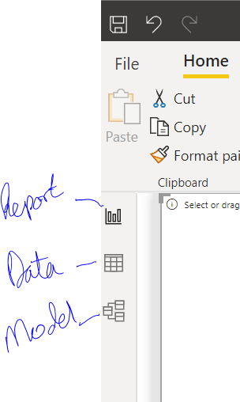
5. On the left navigate to the ‘Data’ section pick ‘Start station latitude’,
6. Go to ‘Column tools’ tab, in properties pick the ‘Data category’ drop down and select ‘latitude’. Repeat for the ‘start station longitude’ but pick ‘longitude’
7. Go back to ‘Report’ .
8. Drag ‘start station latitude’ and ‘start station longitude’ into the boxes named for them in the map visualisation.
9. The map will fill with data.
10. Drag ‘ Trip Duration’ to the ‘size’ box. Click the down arrow to change the data aggregation to ‘count’.
11. Next expand the filters section next to ‘visualisations’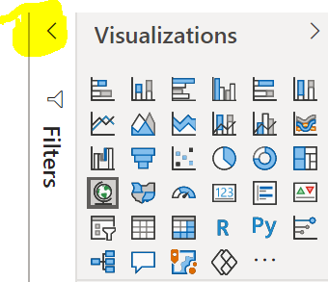
12. Click ‘start station latitude’ in the filters section.
13. Click ‘Basic filtering’ and change to ‘Top N’
14. Type 15 in the box next to ‘Top’
15. Drag ‘ Trip Duration’ into the ‘By Value’ box and change the aggregation to ‘count’ using the drop down button.
16. Click apply filter.
17. Use the paint roller brush format Section to change the title of the map to ’Top 15 Starting Stations’

**Part – 6 Formatting**

We have been doing some formatting as we go, in this section we will focus on Text boxes, images and buttons.

Go to the Formatting Page

1. Go to the ‘Insert’ tab
2. Pick ‘Text Box’
3. Type ‘Citi Bike Dashboard’ and resize the text using the floating bar. Note you need to highlight the text or the changes won’t apply.
4. Resize the text box to avoid excess white space. Note, if you make it too short it will add a scroll bar.
5. Now we will load the logo
6. In the ‘Elements’ section of the ‘Insert’ tab pick ‘Image’
7. Find your logo image in file finder.
8. On the right you will have ‘Format image’
9. Expand ‘Scaling’
10. Pick ‘fill’ then resize the image to be the same height as the text box.
11. In the ‘Elements’ Section pick ‘Button’, ‘Blank Button’
12. On the left you will now have ‘Format Button’ as a section.
13. Expand ‘Button Text’ and toggle it to ‘On’
14. In the ‘Button Text’ box type “Graphs” ( we are going to use this button to go to the Graphs page without using the bottom buttons).
15. Resize the text in the button to 26
16. Make the font ‘ Segoe Bold’
17. You can improve the aesthetics of the button later using the many options (fill, outline, states)
18. Scroll down to ‘Action’ and toggle to ‘on’
19. Expand ‘Action’
20. Change ‘Type’ to ‘ Page Navigation’
21. For ‘Destination’ pick the page we name ‘Graph’.
22. Now if you hold control and click your button it will take you to the Graphs page.

Note: once you publish your graph you won’t need to hold control for buttons to work.

**Part 7 – Publish**

(Sign in before publishing)

1. Graphical user interface, application, chat or text message

   Description automatically generatedSave
2. Home, Publish (all the way at the end)
3. Pick where to publish (My workspace is good)

Note: If you make any changes to the PowerBI file you need to republish and pick ‘replace’ to update those changes.

1. Log in to PowerBI online. Navigate to ‘My workspace’ on the left.
2. You will see the 'data’ and the ‘report’ you published
3. Click the report, then file, embed, website or portal.